**Country analyzer**

A programme that imports data as csv files, stores them as numpy arrays.

Takes in a country as input and ask for what the user might want to know about it.

Then it gives further instructions about what exactly to choose. The choices labelled (graph) have the option to plot a graph of either a comparison of 2 countries or a visual bar representation of all the endangered species.

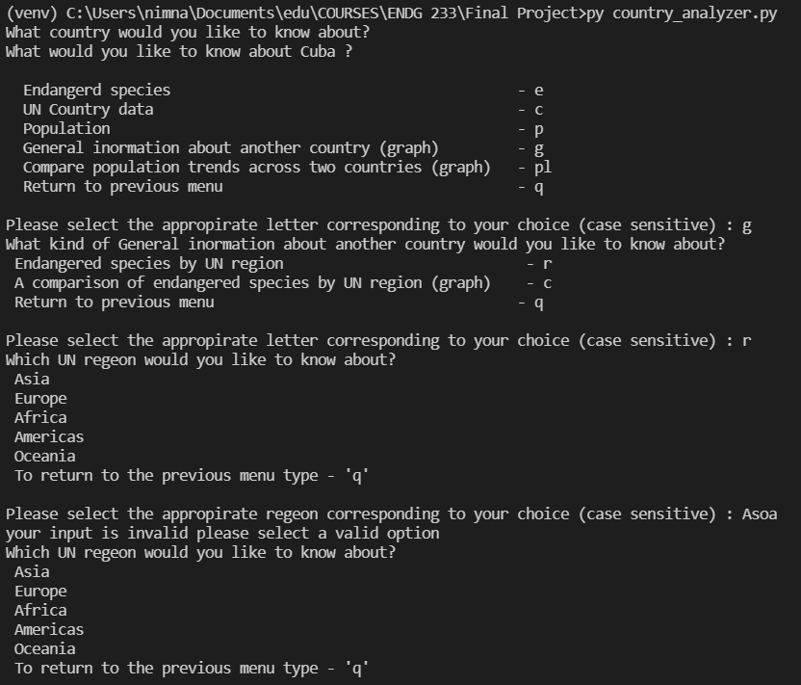



There is also an option to go back to the previous menu if the user wishes to change their option.

The programme only terminates if the user successfully runs the programme and gets an output.

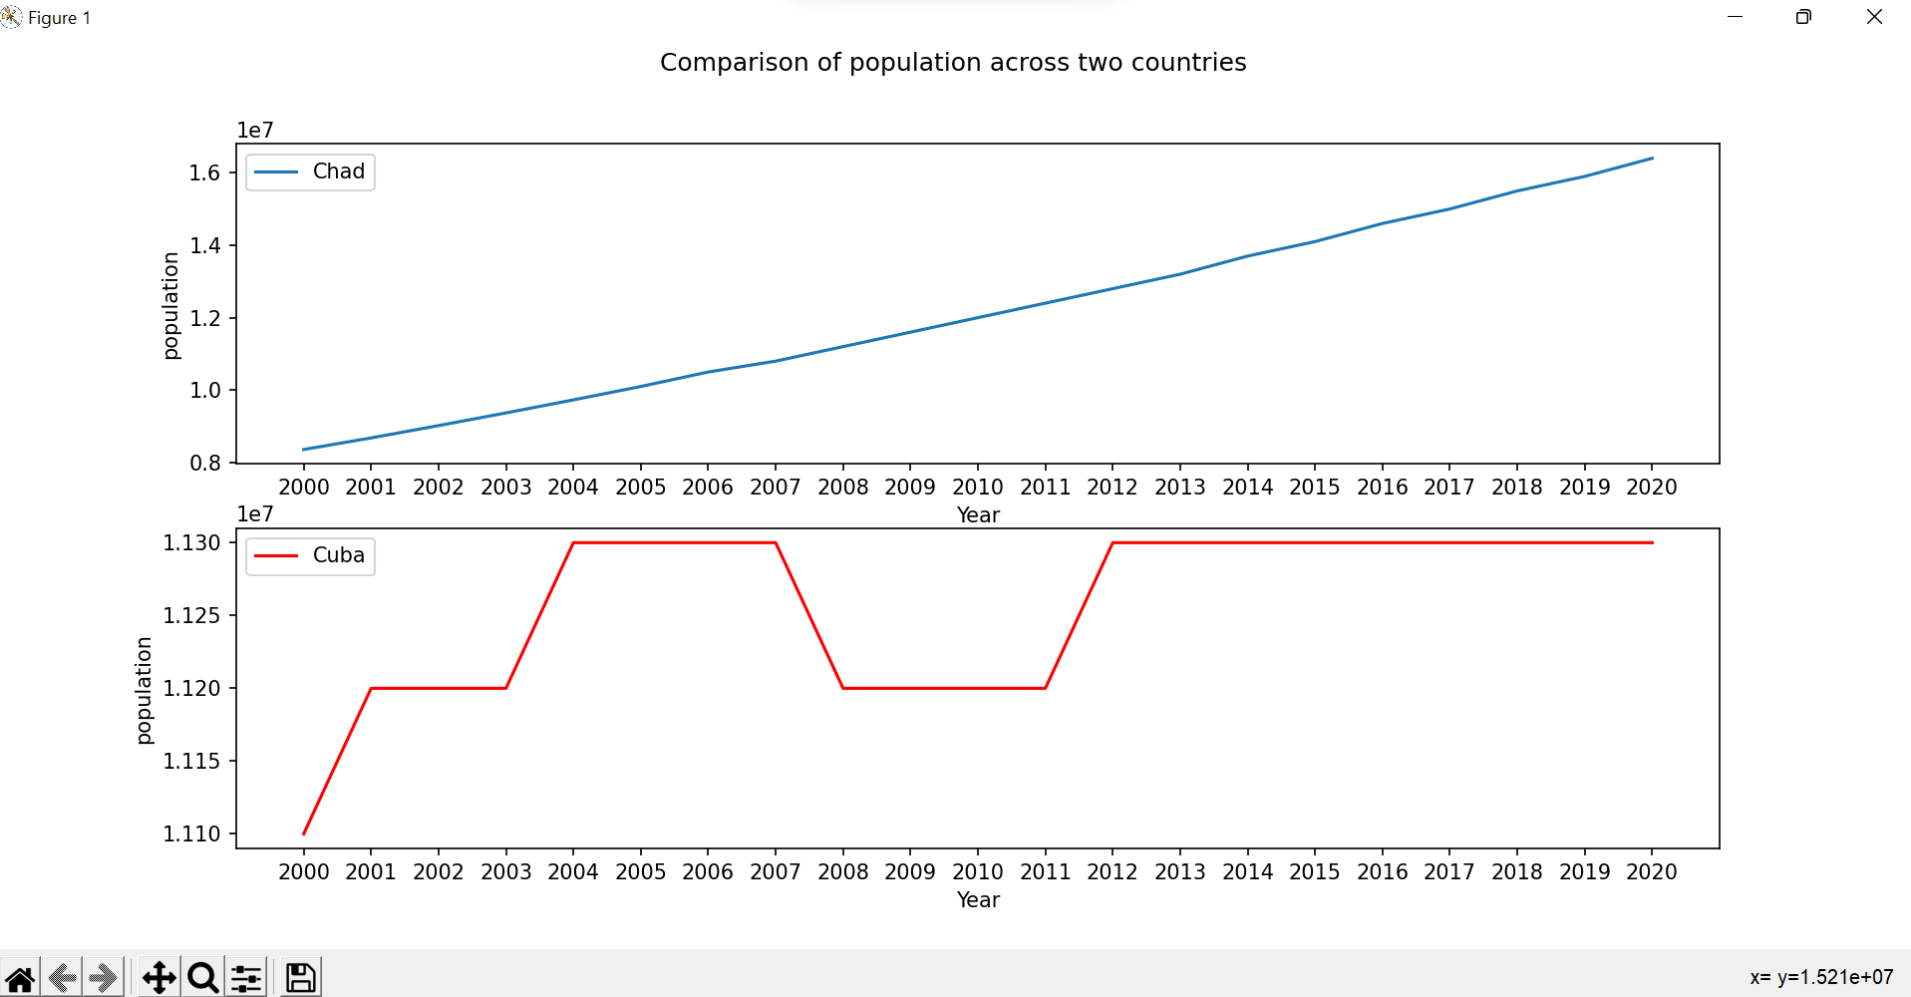

A comparison of the population of Cuba and Chad

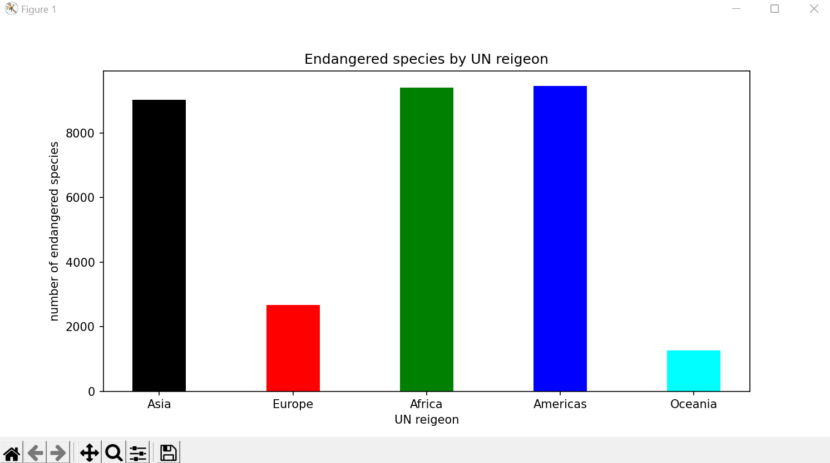

A bar graph visualizing the number of endangered species in each UN region.

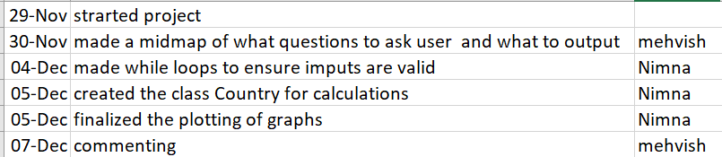

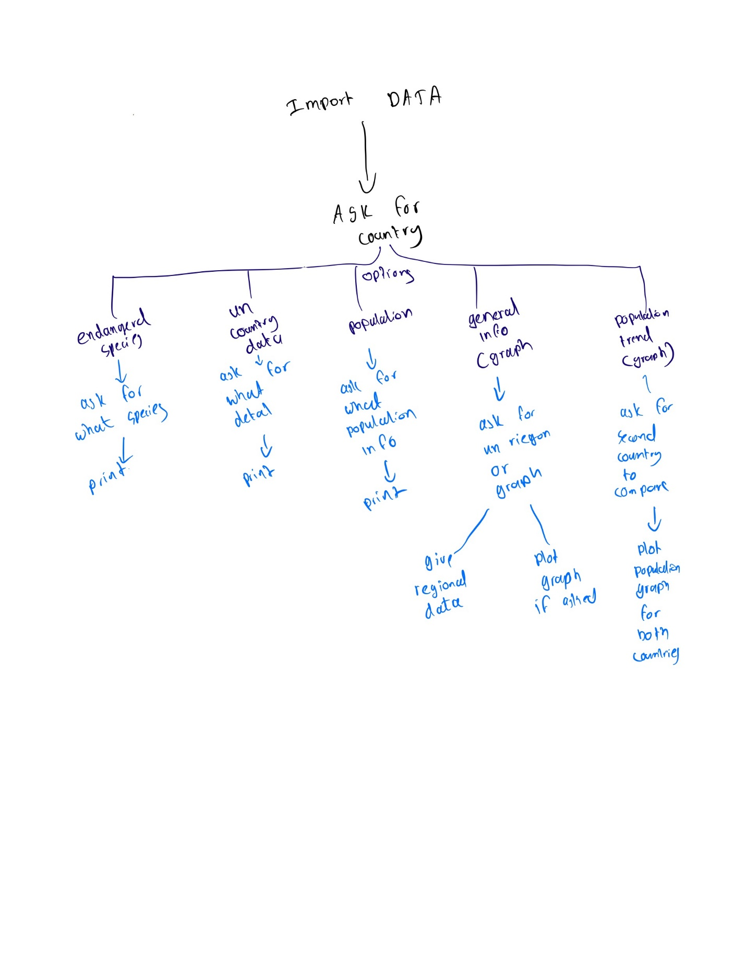

Sources:

University of Calgary, Department of Electrical and Software Engineering, Engineering 233, Programming with Data, Fall 2021.